Chapter 3: Introduction to metabolism
Outline  - The chemistry of life is organized into metabolic pathways  - Organisms transform energy  - Energy transformations of life are subject to two laws of thermodynamics  - Organisms live at the expense of free energy  - Exergonic and endergonic reactions in metabolism  - ATP couples cellular work by coupling exergonic reactions to endergonic reactions  - Enzymes  - Enzymes are substrate specific  - Active site is an enzyme's catalytic center  - Cells's chemical and physical environment affect enzyme activity  - Enzyme inhibitors  - Allosteric regulation  - Metabolic order emerges from the cell's regulatory systems and structural organization.  - Structural order and metabolism | 
Life is a very ordered process. Energy is needed by all living cells. Cells are the ultimate chemical factories, and their molecules are always in a state of flux. Cells constantly destroy and create new molecules using ordered chemical reactions catalyzed by enzymes. As chemical factories, cells are unmatched in their complexity, efficiency, integration, and responsiveness to change. This chapter focuses on cell energetics, important concepts in metabolism, and enzyme function and regulation.
The chemistry of life is organized into metabolic pathways
- Metabolism = totality of an organism's chemical processes.
  - emergent property arising from specific molecules within the orderly environment of the cell.
  - these chemical processes are orchestrated into intricately branched metabolic pathways which alter molecules by a series of steps.
  - involves the management of material and energy resources of the cell
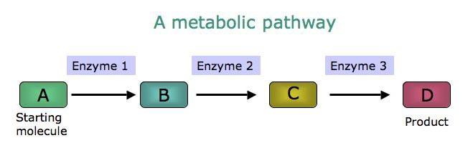
- Catabolic pathways = metabolic pathways which release energy by breaking down complex molecules to simpler compounds (degradative)
- Cellular respiration = major thoroughfare of metabolism in which glucose and other organic fuels are broken down to CO₂ and H₂O.
- Anabolic pathways = consume energy to build complex molecules from simpler ones.
- Energy coupling = coupling of metabolic pathways such that energy released from "downhill" reactions of catabolism can be used to drive the "uphill" reactions of anabolic pathways.
- Bioenergetics = study of how organisms manage their energy resources.
Forms of Energy
- Energy transformations are linked to transformations of matter that occur as chemical reactions in cells.
- Energy = capacity to do work. Exists in various forms (heat, light, electron flow, mechanical etc..)
  - work of life depends on ability of cells to transform energy from one type to another.
- Kinetic energy = energy of motion.
- Potential energy = capacity to do work (i.e. stored energy).
  - chemical energy (a form of potential energy) is stored in molecules due to structural arrangement of the atoms in those molecules.
  - energy is converted from one form to another i.e. potential energy stored in molecules is converted to kinetic energy by rearranging atoms in molecules.
- Cellular respiration and other catabolic pathways unleash energy stored in sugar and other complex molecules and make that energy available for cellular work.
Energy transformations of life are subject to two laws of thermodynamics
- Thermodynamics = study of energy transformations in matter.
- System = any part of the universe we choose to isolate and study (e.g. planet, organism, cell, chemical reaction).
  - Closed system = no interaction with external environment (no energy transferred).
  - Open system = energy can be transferred between a system and its surroundings. Organisms are open systems.
- First law of thermodynamics = energy can be transferred or transformed, but it can neither be created nor destroyed. Therefore, energy of universe is constant.
- Second law of thermodynamics = every energy transfer or transformation increases the entropy of the universe (i.e. no energy transfer or transformation is 100% efficient). This law is why you can't build a perpetual motion machine.
- Entropy = a measure of disorder or randomness.
  - All living things unavoidably convert organized forms of energy to heat (i.e. entropy).
  - Heat is lowest grade of energy. It is the uncoordinated movement of molecules, which many systems can not harness to do work.
  - On a larger scale, energy flows into an ecosystem in the form of light and leaves in the form of heat.
  - As predicted by the second law, living systems increase entropy in their surroundings.
  - High degree of organization in living things does not violate second law.
    - the entropy of a living system may decrease, as long as the total entropy of the universe (system + surroundings) increases.
    - organisms are islands of low entropy in an increasingly random universe.
Organisms live at the expense of free energy
- Free energy = portion of a system's energy that can perform work when temperature is uniform throughout the system, as in a living cell.
G = H - TS
where G = free energy, H = systems's total energy, T = temp (°C+273), and S = entropy.
- This equation says that not all the energy stored in a system (H) is available for work.
- Ordered systems, such as complex molecules, are rich in energy and have a tendency to change to a more stable state.
- In any spontaneous process, the free energy of a system decreases (Fig 8.5).
ΔG = Gfinal -- G start (change in free energy)
or ΔG = ΔH - TΔS
- For a process to occur spontaneously, ΔG must have a negative value. A system must either give up energy or give up order.
- The greater the decrease in free energy, the greater the amount of work the spontaneous process can perform.
- At equilibrium ΔG = 0, because there is not a net change in the system. i.e. a chemical or physical process at equilibrium performs no work. Equilibrium is death for an organism.
Exergonic and endergonic reactions in metabolism
- Based on their free energy changes, chemical reactions can be classified as either:
  - 1. Exergonic reactions ( spontaneous. net release of energy therefore ΔG = negative value)
e.g. C₆H₁₂O₆ + 6O₂ ---------> 6CO₂ + 6H2O
ΔG = -2870 kJ/mole
  - 2. Endergonic reactions ( net absorbance of energy; DG = positive)
e.g. 6CO₂ + 6H₂O ----------> C₆H₁₂O₆ + 6O₂
ΔG = +2870 Kj/mol
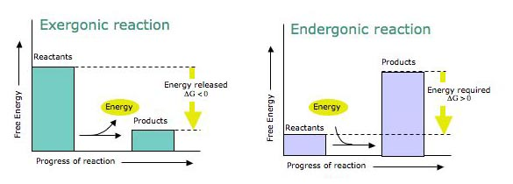
- Metabolic disequilibrium(Fig 8.7)
  - Reactions at equilibrium have ΔG = 0, therefore can do no work.
  - Metabolic disequilibrium is a defining feature of life.
  - Reactions in living systems are kept at disequilibrium by not allowing products of the reaction to accumulate, but rather to use them as a reactant in the next step along a metabolic pathway, until finally CO₂ waste is expelled into the environment.
- Energy coupling uses exergonic process to drive an endergonic one. ATP (adenosine triphosphate) responsible for most energy coupling in cells.
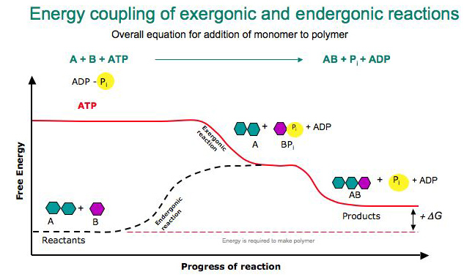
ATP couples cellular work by coupling exergonic reactions to endergonic reactions
- Cells do 3 kinds of work:
  - 1. Mechanical work 2. Transport work 3. Chemical work
- In most cases, immediate source of energy that powers cellular work is ATP (Fig 8.8).
- ATP is closely related to the adenosine nucleotide. ATP differs by having a chain of 3 phosphates attached to the ribose.  - triphosphate tail of ATP is unstable (equivalent to loaded spring), and bonds between phosphate groups can be broken by hydrolysis to yield energy (Fig 8.9).  ATP + H₂O to ADP + Pi  ΔG = -7.3 kcal/mol (note: reverse process absorbs 7.3 kcal/mol)  - the release of energy during the hydrolysis of ATP comes from the chemical change to a more stable condition. | 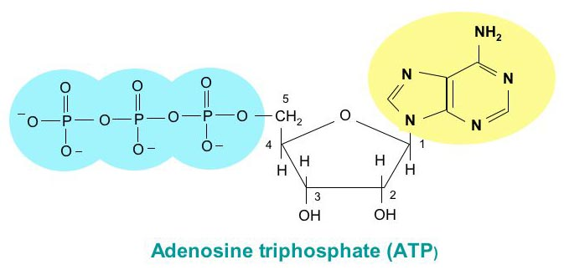
How ATP performs work (Fig 8.10-11)
- With the help of enzymes, cells couple the energy of ATP hydrolysis directly to endergonic processes by transferring a phosphate group from ATP to some other molecule (phosphorylation).
- The key to coupling is the formation of this phosphorylated intermediate which is more reactive (i.e less stable than original).
- Nearly all work in the cell depends on ATP's energizing of other molecules by transferring phosphate groups.
- ATP is regenerated by the addition of a phosphate to ADP. Without this recycling, humans would consume their weight in ATP per day.
- Catabolic (exergonic) pathways provide the energy to make ATP (endergonic).
- Cellular respiration is the stepwise pathway by which enzymes decompose glucose and other complex organic molecules. The process is overwhelmingly exergonic, and the energy it releases drives phosphorylation of ADP to ATP.
- The ATP cycle is a turnstile through which energy passes during transfer from catabolic to anabolic pathways (Fig 8.12).
Enzymes
- The laws of thermodynamics say nothing about rate of reactions. Most spontaneous reactions in the cell would occur at an imperceptible rate without protein catalysts (enzymes).
- Enzymes = catalytic proteins.
- Catalyst = chemical agent that changes rate of a reaction without being consumed in the process. Without enzyme catalysts metabolism comes to a halt.
- Chemical reactions involve the breaking and forming of bonds. The reactant molecules must absorb energy from their surroundings for their bonds to break, and energy is released when bonds of the product molecules are formed ( Fig 8.14).
- Activation energy = energy required to break bonds in the reactant molecules. i.e its the initial energy investment for starting a reaction. Without activation energy, all macromolecules would spontaneously decompose.
- In cells, the activation energy can not come form thermal energy because heat kills cells.  - Cells use enzymes to lower the barrier of activation energy (E_{A}), so that even at moderate temperatures the transition state can be reached.  - Note that enzymes can not change the ΔG for a reaction. Enzymes only speed up reactions that would occur eventually. Enzymes allow cells to have a dynamic metabolism because each enzyme is selective in the reactions it catalyzes (Fig 8.15). | 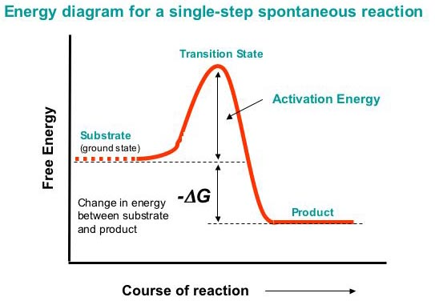
Enzymes are substrate specific
- Substrate = reactant enzyme acts on.
- Enzymes work by binding to their substrate(s). While joined, the catalytic action of the enzyme converts substrate to product.
- Cells contain 1000's of enzymes. Each enzyme catalyzes a particular reaction. This specificity is based on molecular recognition. The specificity of an enzyme based on a compatible fit between the shape of its active site and the shape of its substrate.
- Active site = region on the enzyme which actually binds to substrate.
- Induced fit = change in enzyme shape in response to binding of substrate such that there is a better fit between enzyme and substrate. Brings chemical groups of the active site into positions that enhance their ability to work on the substrate and catalyze the chemical reaction.
Active site is an enzyme's catalytic center
- Substrate binds active site to form enzyme-substrate complex (Fig 8.17).  - Substrate is held in place by weak bonds ( ionic and hydrogen)  - Side chains of amino acid at catalytic site catalyze conversion of substrate to product, then product leaves.  - Entire cycle is very fast (1000's/sec), and enzyme emerges in its original form. Therefore, small amounts of enzyme can have huge impact on rates of reactions. | 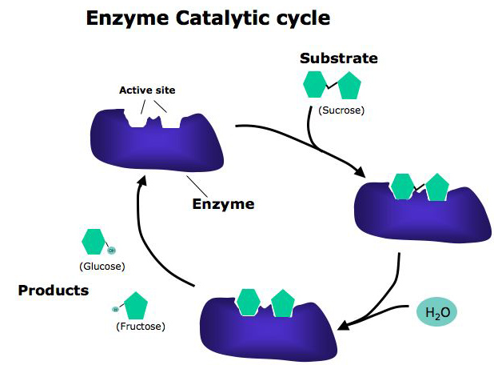
- Enzymes use a variety of ways to lower activation energy.
  - 1. Active site bind substrates together in correct orientation. Induced fit causes stress on bonds in substrate therefore reducing the amount of thermal energy that must be absorbed to achieve transition state.
  - 2. Active site provides suitable microenvironment condusive to a particular type of reaction (eg high or low pH of R groups).
- Rate at which enzyme converts substrate to product is partly a function of initial substrate concentration. However, once active site is saturated, the only way to increase the rate of reaction is to increase the amount of enzyme. Cells do this.
Cells's chemical and physical environment affect enzyme activity
- Effects of temperature and pH (Fig 8.18)
  - All enzymes have an optimum temperature and pH for enzyme activity.
  - Up to a point, increasing temperature causes increase in the rate of reaction because substrates collide with active sites more frequently.
  - Above a certain point, increase in temp causes disruption of H-bonds, ionic bonds, and other weak interactions that stabilize active conformation and the protein molecule denatures.
  - Different enzymes may have different optimums for both temperature and pH, depending on where they function. E.g. enzymes in stomach have a low pH optimum.
- Cofactors = nonprotein helpers essential for catalytic function (Zinc, iron, magnesium, copper etc...)
- Coenzymes = organic cofactors. Many are or are derived from vitamins.
Enzyme inhibitors
- Certain chemicals selectively inhibit the action of enzymes ( Fig 8.19).
- Competitive inhibitors = resemble normal substrate molecule and compete for admission into active site. Reduces enzyme productivity by blocking substrate from entering active site. If binding of inhibitor is reversible, then increasing concentration of substrate should reduce inhibition.
- Noncompetitive inhibitors = impede enzymatic reactions by binding to a part of the enzyme away from the active site, but alters the conformation of the enzyme so that the active site is no longer fully functional.
Allosteric regulation
- Selective inhibition or activation of enzymes by molecules naturally present in the cell are essential mechanisms for metabolic control ( fig 8.20).
Allosteric site = specific receptor site on part of the enzyme remote from active site that binds regulator.
- Most enzymes with allosteric sites oscillate between 2 conformational states, one catalytically active the other inactive.
1. active form stabilized by allosteric activator molecule
2. inactive form stabilized by allosteric inhibitor.
- In some cases, allosteric inhibitor and activator may bind to the same site. E.g. some catabolic enzymes bind both ATP and ADP at allosteric site. When ATP bound, enzyme inhibited. When ADP bound, enzyme activated.
- Allosteric enzymes act as key regulators controlling rates of key reactions in metabolic pathways.
Metabolic order emerges from the cell's regulatory systems and structural organization.
- The operation of each metabolic pathway in the cell are tightly regulated. Metabolic pathways are switched on and off by controlling enzyme activity (Fig 8.21).
- Feedback inhibition = one of the most common forms of metabolic control. Occurs when a metabolic pathway is switched off by its end-product, which acts as an inhibitor of an enzyme within the pathway. Feedback inhibition prevents the cell from wasting chemical resources to synthesize more products than necessary.
Structural order and metabolism
- Cells are not simply bags of chemicals wondering about randomly. There is order and structure (in time and space) to the way they organize their metabolic pathways.
  - enzymes may be assembled as multienzyme complex, with each enzyme's product serving as substrate for next enzyme in complex.
  - some enzymes have fixed locations in cells because they are anchored in the membranes
  - enzymes can be compartmentalized within organelles (e.g. enzymes responsible for cellular respiration reside in mitochondria). This is more efficient since it allows them to be more concentrated.

